Church of Nigeria
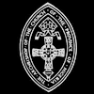
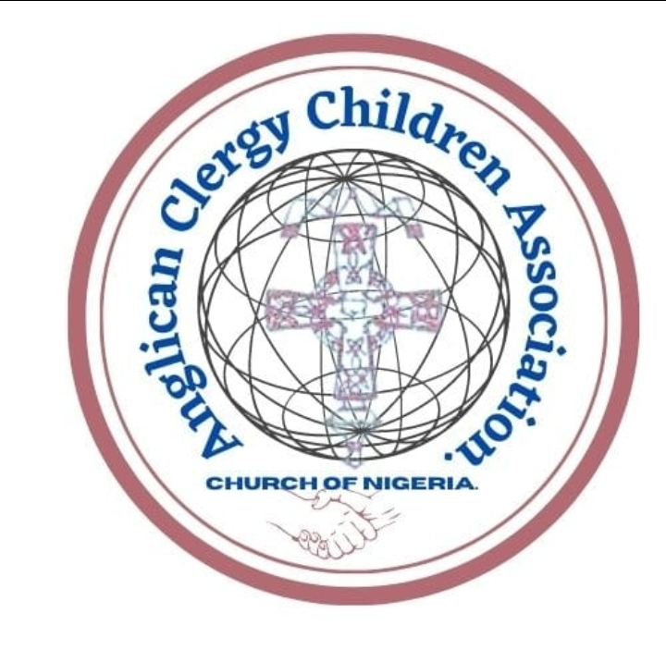
Anglican Communion
ANGLICAN CLERGY CHILDREN ASSOCIATION

A communique issued by the Anglican Clergy Children Association at the close of the 2024 Annual Convention held at St Marks Church Omagba Phase I, Diocese on the Niger, Of the Niger Province from Thursday 12th to Sunday 15th September, 2024.

Introduction
The 2024 Annual Convention with the theme "A Covenant of Everlasting Priesthood," was held at St Marks Omagba Phase I, Onitsha, Diocese on the Niger from Thursday 12th to 15th September, 2024.
The Convention had 1113 registered delegates which cuts across the 14 Provinces of the Church of Nigeria but 852 delegates were present.
We had in attendance, His Grace, the Most Rev’d Henry C Ndukuba, the Primate of all Nigeria and the Most Rev’d Dr Alexander Ibezim, Archbishop of the Niger Province, ably represented by the Rt. Rev’d Dr Owen Nwokolo and his wife, Dr Mrs. Elsie Nwokolo, Bishop Diocese of On the Niger, Rt. Rev’d Oluwagbemiro Fabuluje and Mrs Lydia Fabuluje, Bishop of Oke-Osun Diocese and Bishop Chaplain ACCA, Rt. Rev’d Festus Davies, Bishop of Ogorimangogo Diocese, The Rev’d Godsplan Onukwufor, Rt Hon. Somtochukwu Udeze, the Speaker Anambra State House of Assembly and Delegates during the Opening Ceremony.
And whereas, the Anglican Clergy Children Association (ACCA) is a forum for the Bishops and Clergy Children which cuts across the Nation both serving, retired and departed. We are an integral part of our Parents ministry, being the first recipients of both the blessings and challenges of the ministry. This ministry is unique and special as it has united individuals across all walks of life aiming towards one goal. This shared heritage has shaped our perspectives, values and commitments to the church.

The Convention issues the following communique:
To understand the Theme: A Covenant of Everlasting Priesthood, well
- We should first know that we are called to be God's children and mission partners in fulfilling God's purpose
- For us to function effectively, we should put off the old man in our lives and put on righteousness.
- God's promises are meant to be extended beyond our generation. They are a commitment not just to our parents but to us and our children
- Whether or not we feel prepared, we are called to uphold the values that have been passed down to us.
- Learn to participate actively in the ministry of intercession, teaching and upholding God's laws within our communities. In finding ways to honour God and live out this legacy, we enjoy the blessing attached to the covenant.

- ACCA Trust Fund - ACCA Trust Fund stands as a beacon of hope and support for indigent clergy children across the country. It is not merely a financial resource but a testament to our collective responsibility to uplift and empower the children of those who have devoted their lives to the ministry.
To qualify for this fund, you must be a clergy child that is participating actively at National, Provincial or Diocesan levels. Recommendations from Provincial and Diocesan Leaders fuels the eligibility. Status of one's father whether serving, deceased or retired does not affect eligibility.

- ACCA Constitution - The ACCA Constitution is a legal document put together to enable us have a guide or laid down principles that will help foster the unity of the association and grow the association.
The Constitution was adopted and put into use with immediate effect.

- Election - The Caretaker Committee was officially inaugurated to be the Administrative Council of which their tenure spans for 2 years. After which an election will be conducted and those set of new leaders will lead for 4 years.

Recommendations-
- The Anglican Bishops and Priests are appealed to allow their children participate actively in the association for the purpose of uniting them, having more understanding of their Parents ministry and appreciate their ministry.
- Anglican Clergy are encouraged to have time for their children, create a good learning environment for them to grow both in ministry and other spheres of life.
- Our Fathers are encouraged to follow up their children to know their area of ministry and profession because not all are born to be Priests.

Resolutions
- The conference should be held every 2 years and rotated across the Supras
- Each Province and Diocese that does not have this Association existing to form theirs forthwith.
- Whether Clergy Children ministry, Forum or Fellowship they are all under the umbrella of Association.
- Membership is automatic from the day of birth to the day of death or by legal adoption.

Conclusion
The ACCA appreciates Our Primate, the Host Bishop, Sponsors, Guest Speakers, Caretaker Committee Members, CPC/ LOC members and delegates for their support towards the success of the conference
ACCA has come to stay and by God's grace will move forward.
ACCA ........ Be an example

Signed

Sis Oluoma Chijioke-Nwaobia, Sis Nsanawaji Ukafia,
Chairman, Communique Team Secretary, Communique Team

Rt. Rev’d Oluwagbemiro Fabuluje, Rev’d Godsplan Onukwufor, Bishop Chaplain, ACCA National Chairman.

